**How to create Maven project**

**Maven – build automation tool**

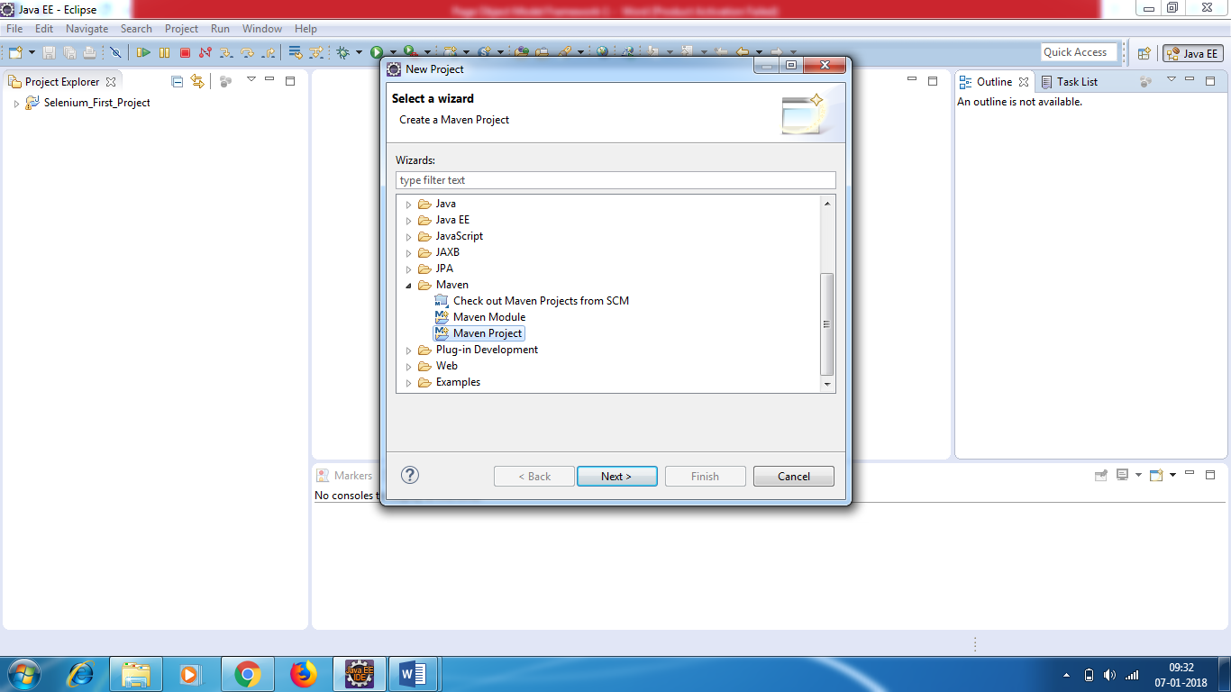

**Click Next**

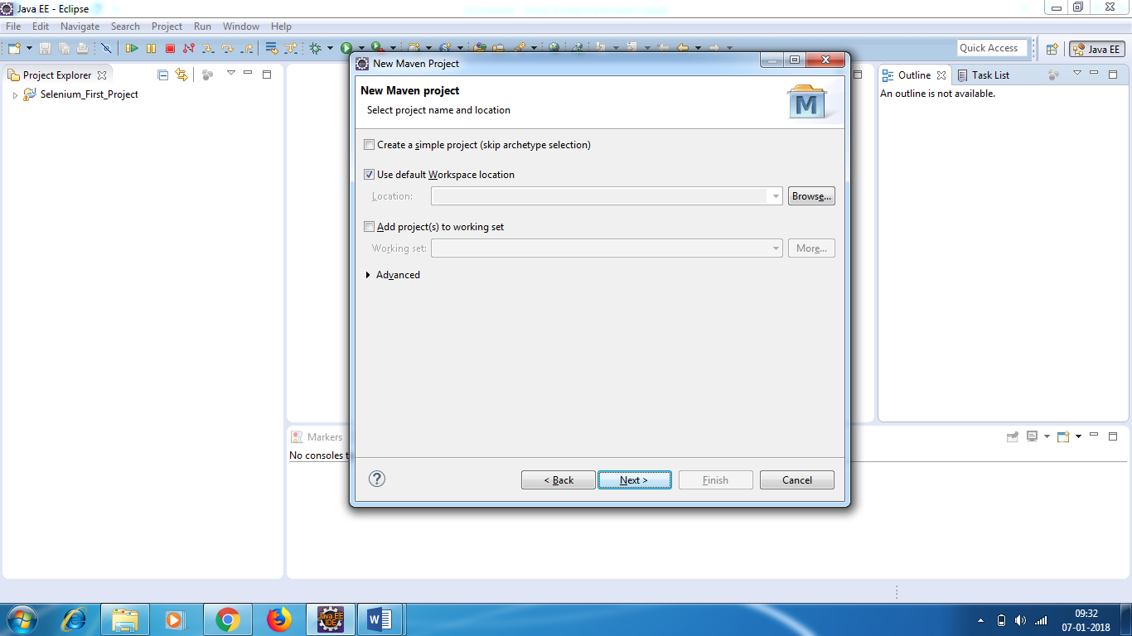

**Do not enter anything , click Next**

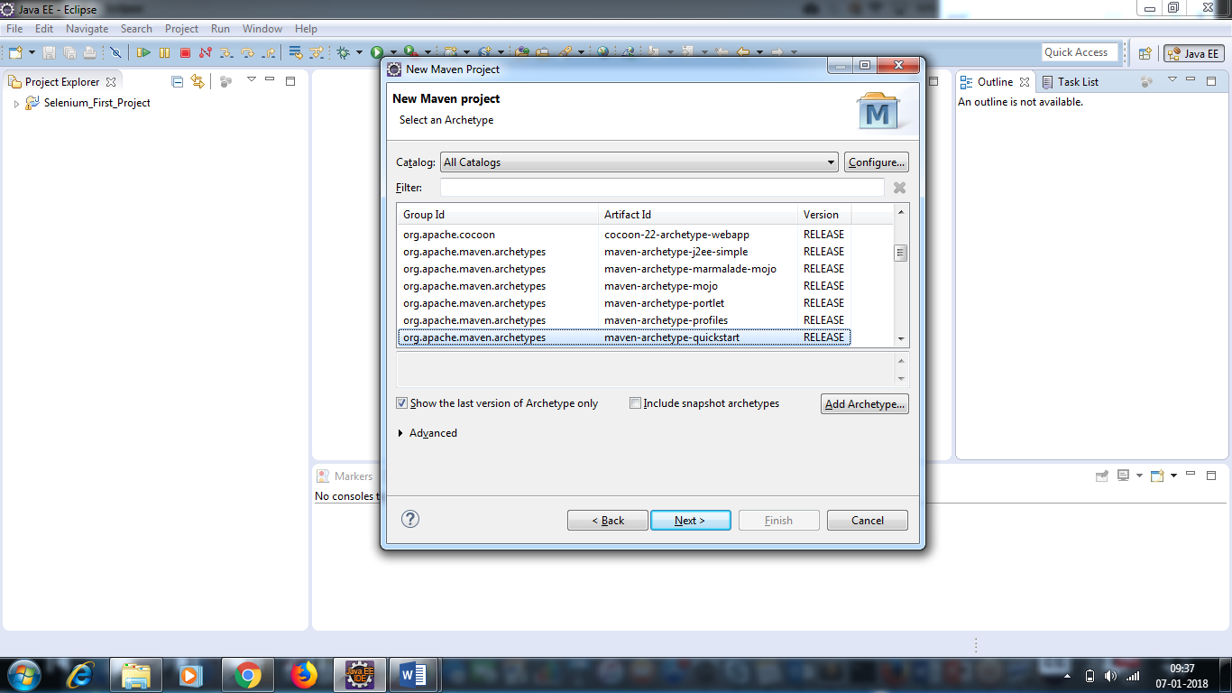

**Don’t change anything, click next**

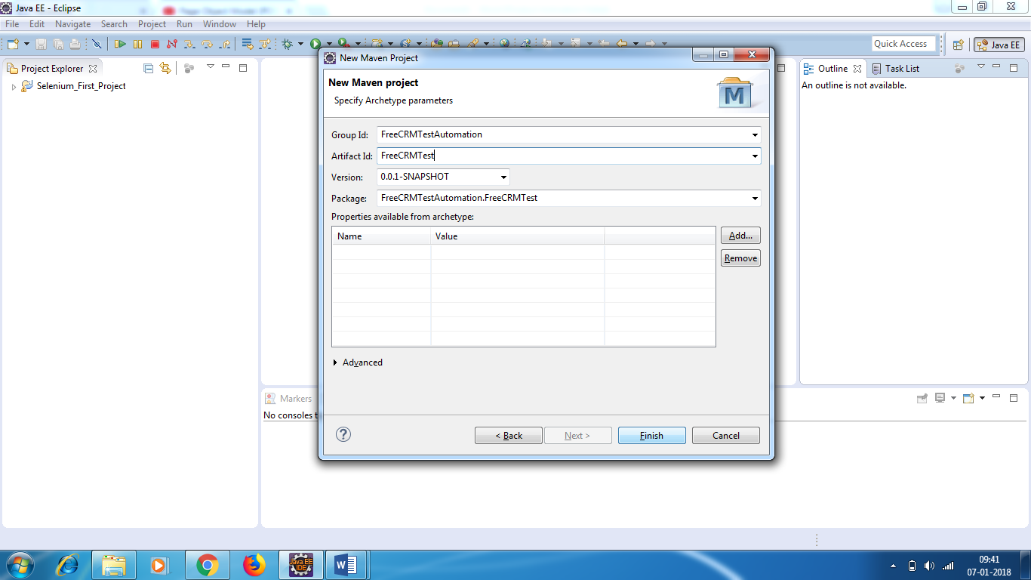

**Group ID: FreeCRMTestAutomation**

**Artifact ID: FreeCRMTest (Project Name)**

**Click Finish**

**Project will be created – Project Name : FreeCRMTest**

**You will see MJ written in the project folder – Maven Java**

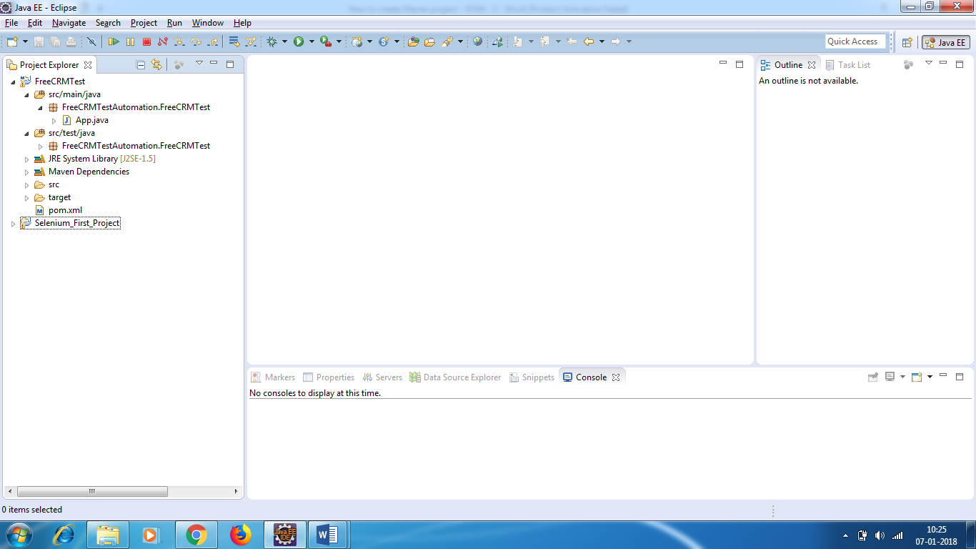

Delete the dummy packages – in main folder and test folder.

We have pom.xml file. We need to add dependencies in pom.xml like Apache POI dependencies, Extent report API.

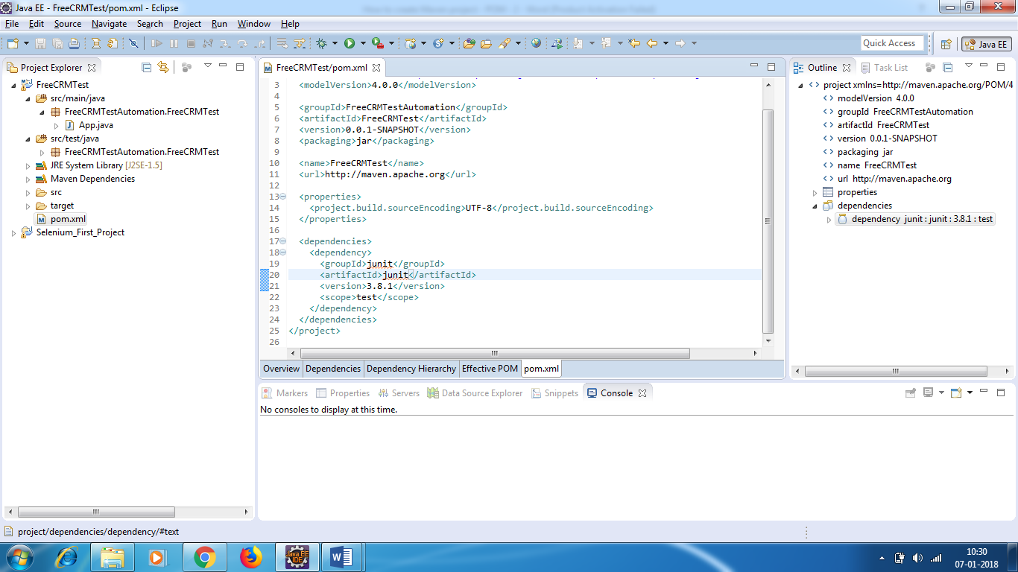

Remove junit dependencies .

* Add selenium dependency

Type Webdriver Maven in google.

<http://docs.seleniumhq.org/download/maven.jsp>

<dependency>

<groupId>org.seleniumhq.selenium</groupId>

<artifactId>selenium-java</artifactId>

<version>3.7.1</version>

</dependency>

* Add TestNG dependency

Type TestNG Maven in google.

http://testng.org/doc/maven.html

|  |
| --- |
| <dependency> |

|  |
| --- |
| <groupId>org.testng</groupId> |

|  |
| --- |
| <artifactId>testng</artifactId> |

|  |
| --- |
| <version>6.8</version> |

|  |
| --- |
| <scope>compile</scope> |

|  |
| --- |
| </dependency> |
|  |

**Change test to compile in scope**

* **Add API POI dependency**

|  |
| --- |
| <dependency> |
|  | <groupId>org.apache.poi</groupId> |
|  | <artifactId>poi</artifactId> |
|  | <version>3.16-beta2</version> |
|  | </dependency> |
|  |  |
|  |  |
|  | <dependency> |
|  | <groupId>org.apache.poi</groupId> |
|  | <artifactId>poi-ooxml</artifactId> |
|  | <version>3.9</version> |
|  | </dependency> |
|  | <dependency> |
|  | <groupId>org.apache.poi</groupId> |
|  | <artifactId>poi-ooxml-schemas</artifactId> |
|  | <version>3.9</version> |
|  | </dependency> |
|  | <dependency> |
|  | <groupId>org.apache.poi</groupId> |
|  | <artifactId>poi-scratchpad</artifactId> |
|  | <version>3.9</version> |
|  | </dependency> |
|  | <dependency> |
|  | <groupId>org.apache.poi</groupId> |
|  | <artifactId>ooxml-schemas</artifactId> |
|  | <version>1.1</version> |
|  | </dependency> |
|  |  |
|  | <dependency> |
|  | <groupId>org.apache.poi</groupId> |
|  | <artifactId>openxml4j</artifactId> |
|  | <version>1.0-beta</version> |
|  | </dependency> |
|  | <dependency> |
|  | <groupId>org.apache.poi</groupId> |
|  | <artifactId>poi</artifactId> |
|  | <version>3.9</version> |
|  | </dependency> |
|  | <dependency> |
|  | <groupId>org.apache.poi</groupId> |
|  | <artifactId>poi-ooxml</artifactId> |
|  | <version>3.9</version> |
|  | </dependency> |
|  | <dependency> |
|  | <groupId>org.apache.poi</groupId> |
|  | <artifactId>poi-ooxml-schemas</artifactId> |
|  | <version>3.9</version> |
|  | </dependency> |
|  | <dependency> |
|  | <groupId>org.apache.poi</groupId> |
|  | <artifactId>poi-scratchpad</artifactId> |
|  | <version>3.9</version> |
|  | </dependency> |
|  | <dependency> |
|  | <groupId>org.apache.poi</groupId> |
|  | <artifactId>ooxml-schemas</artifactId> |
|  | <version>1.1</version> |
|  | </dependency> |
|  |  |
|  | <dependency> |
|  | <groupId>org.apache.poi</groupId> |
|  | <artifactId>openxml4j</artifactId> |
|  | <version>1.0-beta</version> |
|  | </dependency> |

**Config properties contains global properties – username , password , browser , url**

* **Testcases should be separated**
* **Before each test cases launch browser and login**
* **After each test case , close the browser.**